Making Attendance Everyone’s Business ‘Connect Event’

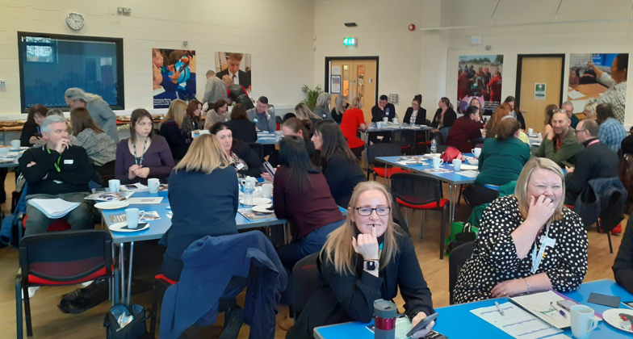
3rd December 2025

Thank you for an amazing day of learning and working together!
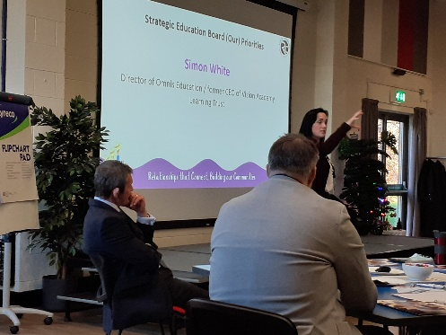
Introduction

Our thanks to the 74 participants at this our second annual in-person Attendance Alliance event bringing together colleagues from the education, public, voluntary and community sectors. Thanks to our guest speaker, Simon White, Chair of the strategic Education Board for sharing his insights and experiences as well as note that attendance is a golden thread across the SEB’s four strategic priorities (SEND, poverty, mental health and contextualised safeguarding).
It was also an opportunity to formally launch our new Attendance Positive Framework for Action which we hope you can use not only in your own setting but also use it as a tool to work together on those actions where you feel any further difference can be made working with others outside your own organisation.
Other new resources have been produced using all your ideas over the past 3 years to shape the Making Attendance Everyone’s Business approach in Redcar & Cleveland including the Attendance Handbook and also the brand new ‘Strengthening Team Around Models’ booklet and case studies if you feel there is even more can be teased out of multi-agency partnership working to support stable attendance and ultimately a sense of belonging for child and family. All these and other useful attendance-related resources are found here for your convenience:
Useful links and resources
Thank you to those who took part in our polls at the event.
- 88% of you said you strongly/agreed that you feel confident explaining why attendance is everyone’s business and what change we’re trying to achieve together which is such an encouraging result for us as an Attendance Alliance.
- 66% of you said you think public services, school/education settings and the VCSE sectors are now more connected and working better together than 3 years ago to support children and families at risk of persistent or severe absence.
- 61% of you said you feel confident using trauma-informed or relationship-centred approaches to support attendance.
- Just over a half of you – 52% - said your ‘team around’ (child / family / school) models of working are better than they were three years ago. We think this result underlines the importance of producing new practical resources dedicated to this topic so please do download and use copies of the new resources found here for you.
Strengthening Team Around models for children - CASE STUDIES 2025 and Strengthening Team Around models in R&C - Resource 2025

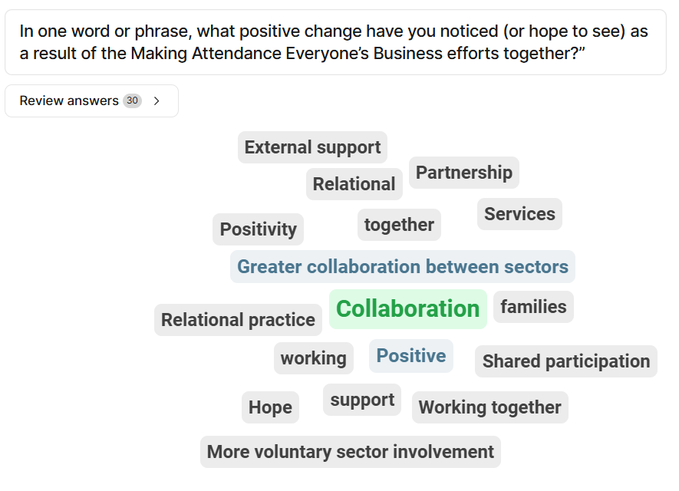
Finally, and most importantly we hope you enjoyed the thematic discussion sessions. These are going to be valuable to the next stage of our work. Here are some notes captured by the Co Leaders at each session in summary form.
Health & Attendance
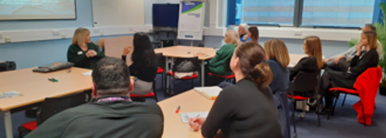
Question 1: How can we align education, health, and community partners around a shared goal of reducing health-related inequalities that impact attendance?
Key Points:
- Positive feedback on the school nursing service.
- Concerns about GP letters authorising absence without the child being seen.
- Occasional conflicts between GP guidance and other professionals (e.g., CAMHS).
- Barriers around information sharing with GPs.
- Need to support parents to feel confident in making informed decisions about school absence.
Suggested Solutions:
- Establish Health Hubs in schools in collaboration with Primary Care Networks (PCNs).
- Strengthen communication and decision-making processes between PCNs and schools regarding pupil absence.
- Support schools to become Asthma Friendly Schools.
Question 2: How can we provide good quality information, advice, and signposting for parents and carers to support their child’s health/mental health?
Discussion Points:
- Is national guidance clear and consistent?
- Are there examples of contradictory advice from health professionals? We felt that there are.
Suggested Solutions:
- Sign up to Making Every Contact Count (MECC) Making Every Contact Count | Redcar and Cleveland
- Subscribe to the HeadStart Newsletter. Redcar and Cleveland: HeadStart South Tees
- Join the Healthier Schools initiative.
- Engage with Health Start.
Question 3: How can MECC, Healthier Together, and HeadStart be embedded in schools so that staff feel confident having health-related attendance conversations?
Key Points:
- Only a few participants had prior awareness of MECC.
- Strong positive response to engaging with MECC, HeadStart, Healthier Schools, Health Start, and Asthma Friendly Schools.
Suggested Solutions:
- Sign up to MECC and access training/resources.
- Subscribe to the HeadStart Newsletter.
- Join the Healthier Schools initiative.
- Engage with Health Start.
- Sign up to Asthma Friendly Schools.
- Liaise with the Healthy Communities Team for local, cross-sector support.
- Collaborate with the VCSE sector.
- Link school aspirations with wider initiatives such as TS6 Pride in Place.
Creativity, Joy, Cultural Participation & Attendance

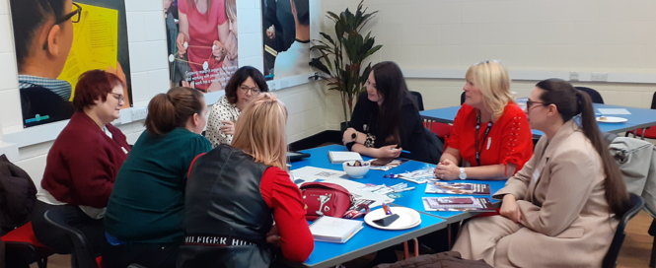
Q1: What would a meaningful ‘Student Cultural Council’ look like in practice, and how could it influence school culture and decision-making?
Schools attending discussions were: Huntcliff, St Peter’s, Nunthorpe and Ryehills alongside other stakeholders from services and VCSE sector.
Key Points:
- Schools participate in Big Big Project, and similar, but find the pupils chosen/who volunteer for these activities are the same names year in/out.
- We asked ourselves the question “Who is not being chosen (and why)/Who are not volunteering (and why)”
- If the young person is absent, vulnerable or disadvantaged in some way (example given, young carer who cannot stay after school) what can an offer look like that is inclusive?
- Do these young people need a “softer” more supportive offer?

- Very apparent that across our schools, communities and services, there are young people without social capital therefore limiting their opportunities later in life, either with work experience, employability or confidence.
- Schools are identifying, through parents, that young people have much smaller friendship groups – those that are face to face/interactive/physical – young people are “locking” themselves away, and we are faced with limited social skills and interaction with their peers.
- The concept of a “Student Cultural Council” was positively met, with views that it is required to be different to other forms of student leadership. Do school councils exist purely to say, ‘oh, we have a school council!’ Do they really have leadership opportunities, do they have a voice?
- Schools recommended, particularly focussing on the point above around friendship, that each School Cultural Council has a representative who attends a “Regional Cultural Council Board,” so that schools interact with each other and the broader community.
- Conversations around the lack of dedicated Drama or Music teachers can impact on the offer to students. Schools were able to offer examples of where gaps in staffing had formed barriers to the offer to young people.
- Schools requested if activities led by the Student Council could then link to transition (so primary to secondary, secondary to FE), with older pupils who develop the offer in the first year and become mentors to younger pupils in the next.
All of this discussion was built on an assumption that young people having a more meaningful voice and influence on decisions can impact the way in which cultural / enjoyment / enrichment can be in place to impact attendance patterns in their school.

Q2: How can creative and cultural experiences help children feel they belong at school – and what evidence can we use to show this links to attendance?
- We have emerging data/impact from the Achieve Programme and Building our Futures activities in Redcar & Cleveland. Evidence is also available from Between the Tides, Kite Festival and other creative projects across the area. How can we collect this evidence into a compelling narrative?
- Do projects make our young people excited to be in school? Insights were shared that children had chosen to attend particular days if clubs or activity/visits were organised on that day.
- Children need to feel that they belong – this is required for the activity too.
- Schools are aware of young people’s personal profiles, their likes/dislikes. Can we focus more on the individual?
- St Peter’s have a new drama teacher, who has created excitement around the young people with what is being planned. There is a “hook” to the learning and attending school as a consequence.
- At Nunthorpe Year 10 students have chosen music as GCSE, but some can’t play an instrument. How can we support this, but make the offer sustainable? RCBC mentioned Orchestra Live and TVMS projects but need additional sustained funding to scale up.
Q3: How can we make sure every child in Redcar and Cleveland has access to at least one meaningful enriching out-of-school activity each week?
- Would it be possible to create some form of “Passport” to capture enrichment stamps? A previous project at St Peter’s held Fresher’s Fairs for Year 7 as part of their transition to secondary, and offered up to 3 activities per week, which were tracked. There was a lack of attendance from those children who had to access school transport home, which then was rectified but wouldn’t have been apparent without the tracking of attendance.
- Consent for activities was an issue. At primary, parents hold that consent. At secondary, it is the choice of the child. Parents are not aware of school clubs, activities or opportunities which they could be supportive to their child signing up.
- Parental engagement as part of the Freshers’ Fair is important but supports transition and links to school staff. Many schools host a Year 7 welcome/meet the tutor etc in early September. Could secondary showcase the “clubs” on offer at Year 5 and 6 open events so capturing the child and parent/carer at same time?
Suggested solutions for our evolving action plan
- Offer a student voice questionnaire to capture not only their thoughts on activity, cultural opportunity but also their health and wellbeing.
- Create a “Shout out” system – schools able to ask for what was missing – equipment, volunteers, resource, knowledge – a simple Google Form could be created and managed to put the “I want” with the “I’ve got” – a bridge to creating a resource-sharing approach between schools and services that can help each other out.
- We need a mapping exercise as staff joining us were not aware of all (if any) opportunities or enrichment for their young people. Some schools potentially only have residential trips (at a cost to parents/carers) or homework clubs.
- Could there be an “Extracurricular Lead” at schools, or at least a direct contact?
- We identified best practice through RCBC Culture team linking with the Holiday Activities Fund (HAF) for the summer and finding those postcodes where young people would not travel out to find activities.
- We need to link to existing community resources and offers (this would link to the ‘Shout Out’ suggestion)
- Could we develop a Male Peers project? Where are the Dads, Grandads, brothers, male peers and positive male role models. A comment was made that Mams attend attendance discussions, but not the Dads or male relatives. Could we create something around young men, who need the role model, but link this to creativity and culture – learning perhaps from some of the creative transition activity catalysed by the MAEB Project and funded by Big Local in Loftus with Freebrough Academy in July 2025?

Targeted Response

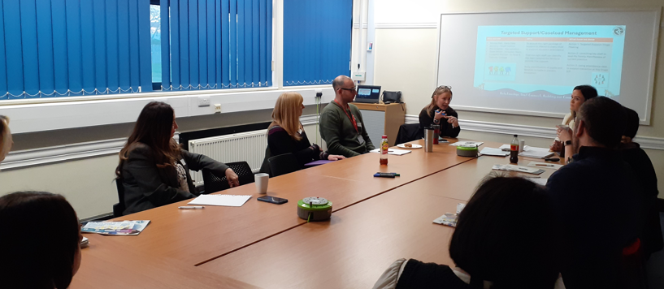
Q1: How might a borough-wide triage model improve coordination for children with multiple or overlapping needs?
- Stakeholders agreed that a coordinated response involving school and multi-agencies makes sense and asked: ‘who would we invite’ to the triage meeting and ‘what about consent?’
- Mo Mowlam reported as doing the multi-agency meetings already where ‘Team around the school’ is increasing naturally.
- One primary school asked is it better to do a vulnerable learner pupils meeting and a triage or instead to merge the meetings? The group consensus was probably to do it as one meeting.
- Consent to share information about the students to be discussed by multi agency partners and school staff would be helpful but there does need to be a conversation with parent / child to do this.
Question: How did staff completing the triage meeting together feedback to parents given they weren’t in the meeting itself?
Answer: The school invited parents in and shared the actions suggested

Key Takeaways:
- Earlier intervention ‘as soon as possible’ is better for everyone, as soon as problems start to emerge for the student
- Opportunity to take this triage model into primary schools as the pilot being discussed here had been in a secondary school in Redcar
Information sharing – making sure parents and children are informed / receive feedback
Solutions
- A How to Guide for the new tirage approach trialled by St Peter’s Catholic College and discussed in these sessions would be useful
- A directory of available people and where they can work from the local authority, health and youth justice
- The Supporting families toolkit | Redcar and Cleveland was mentioned and someone commented that it could be ‘cumbersome in terms of agencies sometimes’
Note some new resources are available that respond in part to these ideas:
Redcar & Cleveland useful links and resources
Attendance Handbook
Attendance Handbook supporting files (ZIP file)
Strengthening Team Around models for children - CASE STUDIES 2025
Strengthening Team Around models in R&C - Resource 2025

Q2: What skills, tools, training, development, or support structures do ‘Lead Practitioners’ need to effectively coordinate attendance interventions across agencies?
- Look at merging the paperwork e.g. attendance plans and Our Family Plans
- CPD for school staff around Our Family Plans and how to complete them
- Active workshop, in person or on Teams to be offered, once every half term
- Early Help Coordinators to into schools and help complete an Our Family Plan and show good practice examples
- ‘Difficult conversations’ training would be helpful.
- Trauma informed responses and behavioural policies knowledge sharing / upskilling would be helpful as trauma-informed responses are needed in schools.
Key Takeaways:
- There was value in rebuilding behavioural policy in a school in Dormanstown to reflect trauma informed practice, perhaps this can inspire others to explore the approach?
- The tension between behavioural policy and trauma informed practice was recognised by people attending these discussions.

Q3: What does good multi-agency problem-solving look like in practice, and how can we make it the norm rather than the exception?
There wasn’t time to cover this question on this occasion, but Co Leads can revisit this in future meetings with stakeholders wishing to get more involved in supporting each other with their targeted response in Redcar & Cleveland.

Mentoring, coaching and peer support
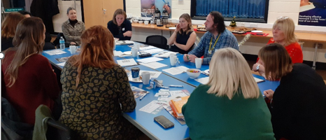
Q1: How can we strengthen the quality and consistency of mentoring, coaching and peer support so that every young person receives relational, not transactional, support?
- Community-based working can break down barriers for school attendance. We need a holistic approach to tackle health, wellbeing, mental health and self-esteem alongside attendance.
- Start where young people are stuck; working / meeting young people outside school e.g. social activities, outdoors, needs-based.
- Local experience has demonstrated the importance of a ‘getting to know you’ session first & meeting practical needs e.g. food!
- Important role of the trusted adult and them being independent of the school and important to support and train mentors and also training for school staff – requested by the schools. Time and availability of mentors key to embed them into school
- Perseverance is key, personalised to the young person’s needs.
- Consistency and long term work / provision is important.
- Give young people the choice about ending, increasing their autonomy over the relationship and their choices about what to work on.

Questions:
- Could all schools have a full time mentor? How could this be financed?
- Could this spend prevent higher spending later since situations have become more complex?
Q2: What are the best ways to evidence the impact of mentoring, coaching and peer support on attendance and wellbeing?
We can measure outcomes with a wellness star e.g. as used in the Turning Tides funded project.
- We could learn from the independent evaluation of the Achieve Education Programme pilot once results are available for publication (2026), which has significant investment in youth mentoring for students in Years 7 to 10. Mixed methods and longitudinal analysis help evidence progress for students re: intentional outcomes linked to frameworks with strong provenance (Anglo American & Woodsmith Foundation-funded).
- Learn from EEF trials / evaluations of peer support interventions linked to attendance.
- Learn from HeadStart and their approach to training pupil wellbeing champions (‘Headstarters’) in schools in Redcar & Cleveland.
- Sharing data between health system / service partners and schools e.g. frequent GP visits need to get flagged up with schools.
Question: How could this be done with data protection?
Q3: How can we embed the role of the trusted adults and peer mentors into schools?
- It feels important for primary age children as well as older young people.
- Getting the Headteacher from the school on board is key.
- Budgets need to be provided as schools are struggling to find money to pay for this.
- Training staff within school can sometimes have more impact than buying in external services – this can also work the other way!
Parental communication, engagement and lived experience
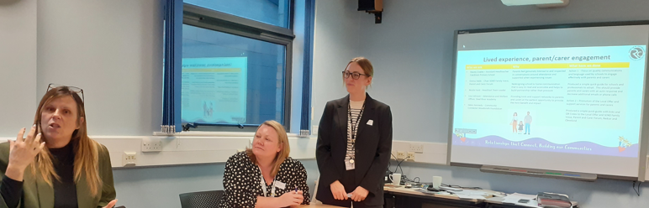
Q1: What would it take for every parent to feel genuinely listened to and respected in conversations about attendance?
- Invite parents in for a cuppa and a chat.
- Informal meetings and get togethers.
- Drop ins at different rimes of different days
- A mix of online and in-person drop ins
- Seek out common ground.
- Establish informal parent group – different to a formal PTA. This parent group may start small with 2-3 willing parents, including those with children that are struggling with their attendance. Invite them into something creative e.g. would you like to help the school prepare the Christmas grotto; and build from that point of practical action, allowing trust and bonds to form slowly.
‘In our school over 70% of students are pupil premium and high levels of economic inactivity in families. Some of our parents were happy to help us out, giving them something to do. The group may then slowly snowball, and you can tackle trickier topics as the group engages over time.’

Q2: How can we redesign school-home communication so that it is easy to understand, accessible, and builds partnership rather than pressure?
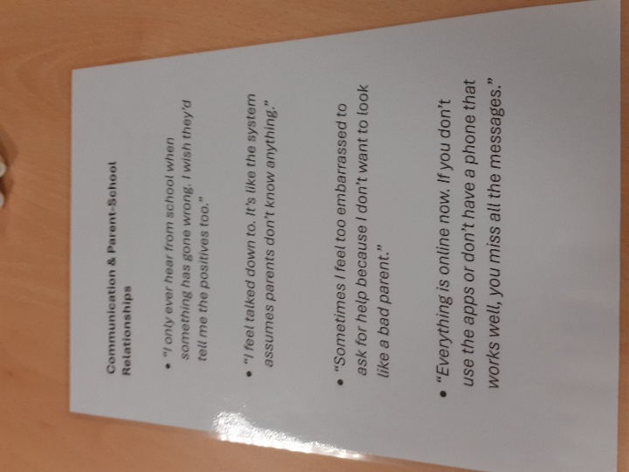
Co Leads shared examples of how communication can look and create different emotional reactions when it goes out to parents. They explored what ‘better’ might look like and have started to produce some simple resources and exemplars to be shared across the Attendance Alliance.
- Reach more parents using apps
- Class charts – texting function (parent communication)
- Use Bromcom
- Reduce letters and make them easy read
Q3: How can we embed lived experience - through parent feedback, coffee mornings, or Local Offer input - into continuous improvement of attendance practice?
- Drops in and informal get togethers
- Ensure the overall aim of embedding lived experience is happening once a term and taking different forms whether through specific activities and engagement events linked to the season.
Quick win actions in the emerging plan. Co Leads commented that when discussing the quick wins all schools nodded in agreement and reflected that it seemed challenging for schools in the discussion groups to do anything ‘over and above’ to try and engage with parents.
Relational Practice
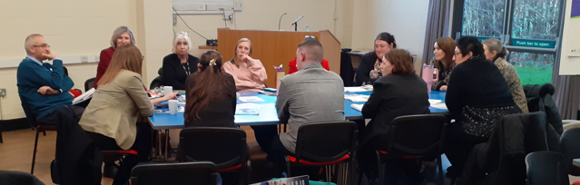

Q1: What would it look like if every interaction with a child or family in Redcar & Cleveland was ‘relational’ rather than procedural?
There were lots of examples given of how relational practice is already happening and positive insights highlighted from the engagement with Newcastle City Council and Devon County Council’s approach and the Redcar and Cleveland Children and Families model.
Key points:
- Improved relations with families and children / connection in a meaningful way.
- Greater partnership and all taking accountability.
- Better wellbeing of staff.
- Improved outcomes for children, better behaviour, less suspensions and improved attendance.
- Academic outcomes have improved following implementation of relational practice strategies.
- Meetings with families, talking to children and parents - 'bridging the gap' between families and school leaders and building families' confidence.
- Every interaction is positive affirmation - college has seen a 3% rise in attendance with this approach.
- Capacity for relational practice is an issue. There aren't enough people to go out knocking on doors.
- Educational Psychology support without having to make referrals would be favourable.
- Working with some families takes a disproportionate amount of time
- Many schools feel they already have relational practice in place, some not fully embedded or used by some staff but not all.
- Consideration that one policy doesn't always work for every family
- Working with SEND children can dominate the resources in place and limits wider capacity.
- More work with parents is needed as some are reluctant to take responsibility.
- All very positive about the 'Adults First' model (Christine Sketchley) but feel more is required – how do we make this scalable.
- Services such as Inside Out are helpful, but parents often disengage.
- How can agencies work together to take the load off schools?
- Lived experience of the child should be at the centre.
- Loss of Sure Start has had an impact.
Q2: What would be the benefits for schools /colleges to move from a behavioural policy to a relational policy
- There were some concerns about the impact this would have on resources and staff time, which is already stretched.
- Relational practice is happening in school, but how do we bring others into this, with shared responsibility.
- Examples given where a relational policy and practice model had improved outcomes for young people where it had been implemented systemically. Redcar and Cleveland colleges have seen improvements in both retention and attendance (3%) of students, and they are seeing that students feel a real sense of belonging.
- There were suggestions that sometimes there are misunderstandings and fear of some parents / carers and that a relational approach could break down barriers, build and heal relationships.
- There were examples provided of good relational approaches but recognising that this was held by some key roles, e.g. attendance who often bridged the relationship between parents and the Head Teacher.
- There were questions raised about how it could be consistently applied by all staff and how you could measure this was happening.
- A quick win could be a network / community of practice (Trauma informed leads in every school). Suggestion that EEF could support this.
Q3: How can leaders create the conditions for relational practice to thrive across schools and services?
- They would need support to implement to avoid any further burdens on school. The 12 days of support that the Devon schools had received was seen as positive but also raised questions about staff capacity to engage in the support.
- Newcastle City Council had recognised that a different model was needed for secondary, but the conditions had been created well for primaries.
- The Devon model had leaders onboard at the start and throughout the process and a senior lead sat on both the practice and strategic group to provide the thread that runs through both.
- Participants felt that staff want to adopt relational approaches, but that CEOs would need to be onboard and drive it at Trust level.
- New Ofsted Framework (Inclusion) was highlighted to support potential ‘buy in.’ It was viewed that Leaders needed to be visible and supportive and be the champion for this.

Q4: What simple, practical changes could we make tomorrow that would help children and families feel more understood and supported?
- Find a connection with a family as a way in.
- Consider how welcoming the environment is.
- Need to break down the barriers in the perceptions of the community.
- Celebrate small steps of achievement through direct conversations with individuals.
- Good transition information is helpful.
- Every member of staff should make x number of positive contacts per week.
- Training needs to be offered to wider staff team, including lunch staff etc.
- Giving praise and the impact this has on children and staff, as opposed to focussing on deficits.
- The book 'when the adults change, everything changes' is helpful.
Quick win actions in the emerging plan.
- Mapping what is already happening.
- Develop a wider working group to look at different models in more detail / determining how we want to move this forward.
- Explore how the ‘Adults First Model’ could be scaled up.
- Development of relational / trauma informed community/ network of practice (mutual support and sharing best practice). Potentially supported through Education Endowment Foundation (EEF) / North Yorkshire Coast Research School.
- Have a Relational / Trauma informed lead in each educational establishment.
Want to get more involved?
Interested in joining one of our new MAEB Co Leadership Groups? Find out more here: Co-leadership
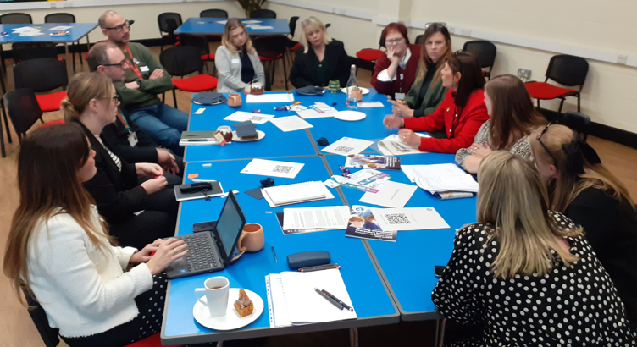
Want to connect with particular people, organisations or some of the practical ideas in these notes?
Co Leads will meet again in early 2026 to agree a schedule of engagement opportunities for 2026, and you are invited to become a part of these groups / communities of practice to share experiences, learning, practical tips and resources helping your organisation, students, families and services connected across Redcar & Cleveland to address the attendance challenge we face together.
Please contact: Amanda Olvanhill, Head of Post-16 Progression and Careers, Education Service, Redcar & Cleveland Borough Council. T: 07870 158812 or Email: amanda.olvanhill@redcar-cleveland.gov.uk and / or Alan Graver, (MD) Skyblue Research Ltd T: 0794 000 4560 Email: alan@skyblue.org.uk
Keep up to date with latest ‘MAEB’ Project news and learning here:
www.skyblue.org.uk/attendance

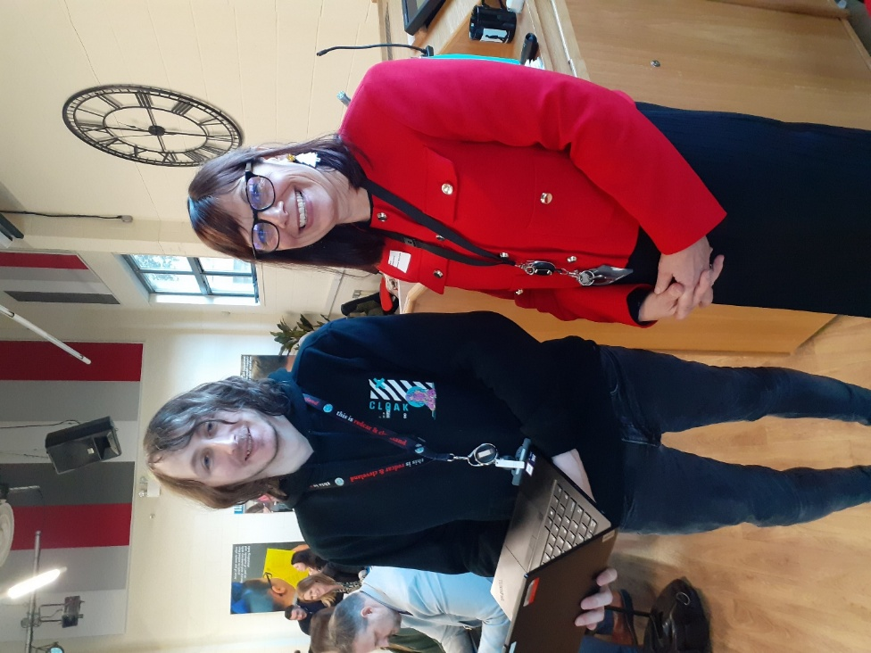

https://www.skyblue.org.uk/attendance/useful-links.html
https://bromcom.com/

